|  |  |  |  |  |  |
| --- | --- | --- | --- | --- | --- |
| **NEFROLOGO** | | | | | |
|  | | Frecuencia | Porcentaje | Porcentaje válido | Porcentaje acumulado |
| Válido | ALVAREZ SANDOVAL EDUARDO | 23 | 51.1 | 52.3 | 52.3 |
| DOMINGUEZ REYES JOSE OCTAVIO | 1 | 2.2 | 2.3 | 54.5 |
| PORTILLO CARRILLO MARTHA VERONICA | 2 | 4.4 | 4.5 | 59.1 |
| SALINAS MENESES AUGUSTO OCTAVIO | 3 | 6.7 | 6.8 | 65.9 |
| TELLO DIVICINO TANIA LETICIA | 15 | 33.3 | 34.1 | 100.0 |
| Total | 44 | 97.8 | 100.0 |  |
| Perdidos | Sistema | 1 | 2.2 |  |  |
| Total | | 45 | 100.0 |  |  |

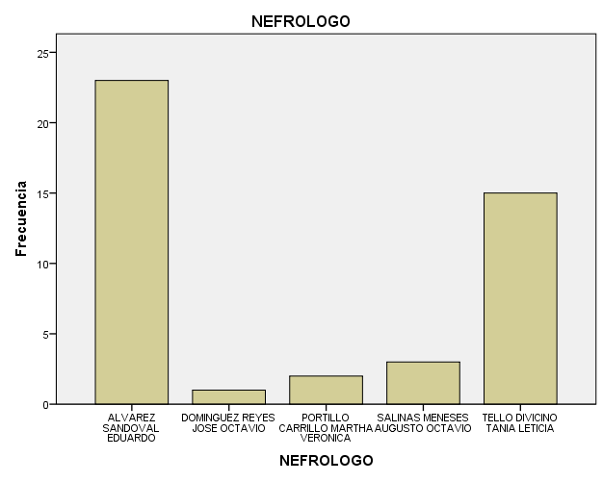

|  |  |  |  |  |  |
| --- | --- | --- | --- | --- | --- |
| **NUMERO DE REBIOPSIA** | | | | | |
|  | | Frecuencia | Porcentaje | Porcentaje válido | Porcentaje acumulado |
| Válido | 1° | 43 | 95.6 | 97.7 | 97.7 |
| 2° | 1 | 2.2 | 2.3 | 100.0 |
| Total | 44 | 97.8 | 100.0 |  |
| Perdidos | Sistema | 1 | 2.2 |  |  |
| Total | | 45 | 100.0 |  |  |

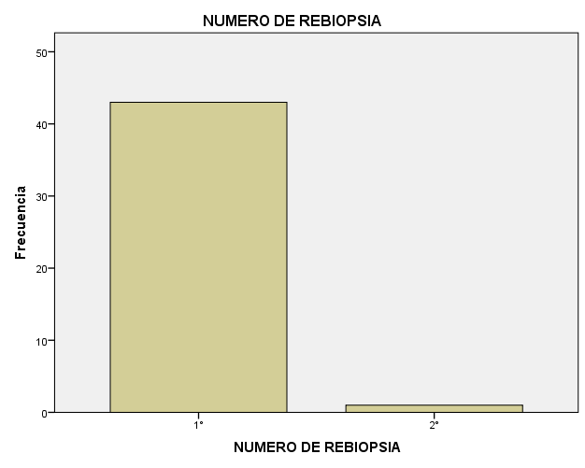

|  |  |  |  |  |  |
| --- | --- | --- | --- | --- | --- |
| **REGION DE PROCEDENCIA DEL PACIENTE** | | | | | |
|  | | Frecuencia | Porcentaje | Porcentaje válido | Porcentaje acumulado |
| Válido | ACAPULCO | 13 | 28.9 | 39.4 | 39.4 |
| COSTA CHICA | 7 | 15.6 | 21.2 | 60.6 |
| COSTA GRANDE | 2 | 4.4 | 6.1 | 66.7 |
| CENTRO | 7 | 15.6 | 21.2 | 87.9 |
| LA MONTAÑA | 3 | 6.7 | 9.1 | 97.0 |
| NORTE | 1 | 2.2 | 3.0 | 100.0 |
| Total | 33 | 73.3 | 100.0 |  |
| Perdidos | Sistema | 12 | 26.7 |  |  |
| Total | | 45 | 100.0 |  |  |

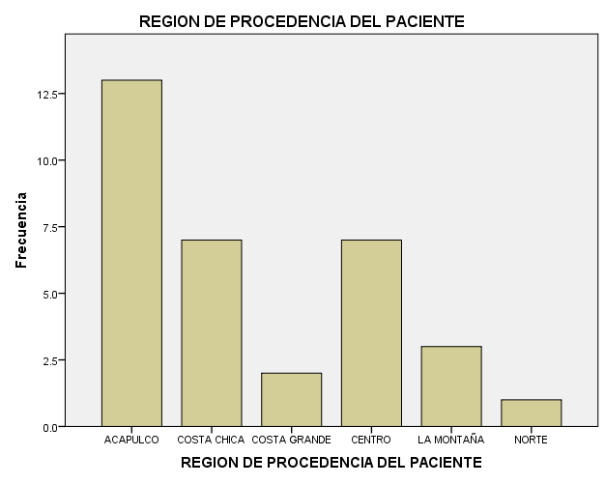

|  |  |  |  |  |  |
| --- | --- | --- | --- | --- | --- |
| **SEXO DEL PACIENTE** | | | | | |
|  | | Frecuencia | Porcentaje | Porcentaje válido | Porcentaje acumulado |
| Válido | MASCULINO | 19 | 42.2 | 43.2 | 43.2 |
| FEMENINO | 25 | 55.6 | 56.8 | 100.0 |
| Total | 44 | 97.8 | 100.0 |  |
| Perdidos | Sistema | 1 | 2.2 |  |  |
| Total | | 45 | 100.0 |  |  |

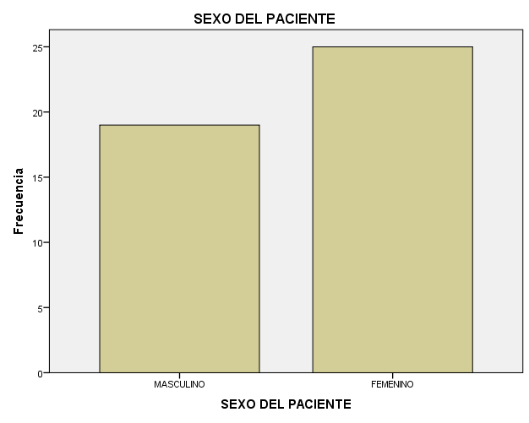

|  |  |  |  |  |  |
| --- | --- | --- | --- | --- | --- |
| **COMORBILIDAD** | | | | | |
|  | | Frecuencia | Porcentaje | Porcentaje válido | Porcentaje acumulado |
| Válido | DIABETES MELLITUS | 5 | 11.1 | 11.9 | 11.9 |
| HIPERTENSION ARTERIAL | 7 | 15.6 | 16.7 | 28.6 |
| LUPUS ERITEMATOSO GENERALIZADO | 6 | 13.3 | 14.3 | 42.9 |
| NINGUNA | 21 | 46.7 | 50.0 | 92.9 |
| OTRAS | 3 | 6.7 | 7.1 | 100.0 |
| Total | 42 | 93.3 | 100.0 |  |
| Perdidos | Sistema | 3 | 6.7 |  |  |
| Total | | 45 | 100.0 |  |  |

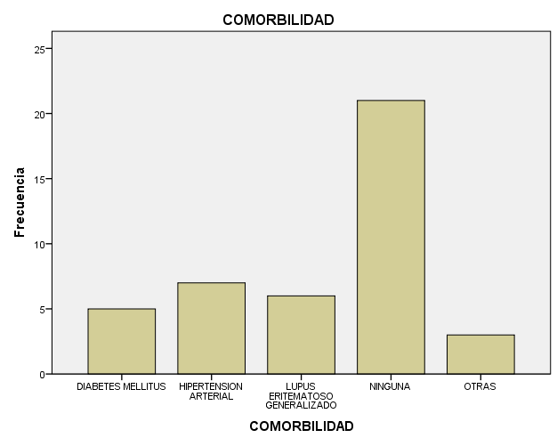

|  |  |  |  |  |  |
| --- | --- | --- | --- | --- | --- |
| **AÑO EN QUE SE REALIZÓ LA BIOPSIA RENAL** | | | | | |
|  | | Frecuencia | Porcentaje | Porcentaje válido | Porcentaje acumulado |
| Válido | 2002 | 1 | 2.2 | 2.3 | 2.3 |
| 2003 | 2 | 4.4 | 4.7 | 7.0 |
| 2004 | 1 | 2.2 | 2.3 | 9.3 |
| 2005 | 3 | 6.7 | 7.0 | 16.3 |
| 2006 | 1 | 2.2 | 2.3 | 18.6 |
| 2007 | 1 | 2.2 | 2.3 | 20.9 |
| 2009 | 2 | 4.4 | 4.7 | 25.6 |
| 2010 | 1 | 2.2 | 2.3 | 27.9 |
| 2011 | 3 | 6.7 | 7.0 | 34.9 |
| 2012 | 12 | 26.7 | 27.9 | 62.8 |
| 2013 | 8 | 17.8 | 18.6 | 81.4 |
| 2014 | 4 | 8.9 | 9.3 | 90.7 |
| 2015 | 4 | 8.9 | 9.3 | 100.0 |
| Total | 43 | 95.6 | 100.0 |  |
| Perdidos | Sistema | 2 | 4.4 |  |  |
| Total | | 45 | 100.0 |  |  |

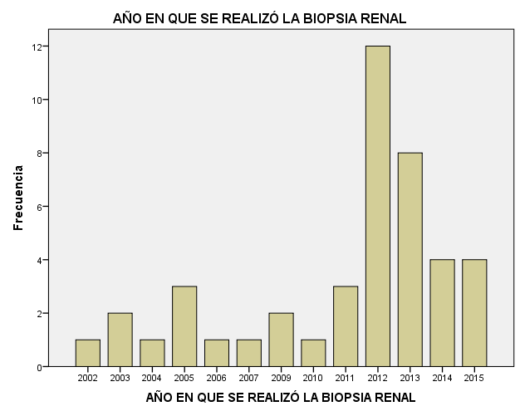

|  |  |  |  |  |  |
| --- | --- | --- | --- | --- | --- |
| **SINDROME CLINICO DE PRESENTACIÓN** | | | | | |
|  | | Frecuencia | Porcentaje | Porcentaje válido | Porcentaje acumulado |
| Válido | GLOMERULONEFRITIS AGUDA | 1 | 2.2 | 2.3 | 2.3 |
| GLOMERULONEFRITIS RAPIDAMENTE PROGRESIVA | 2 | 4.4 | 4.5 | 6.8 |
| ANORMALIDADES URINARIAS PERSISTENTES | 2 | 4.4 | 4.5 | 11.4 |
| SINDROME NEFROTICO | 29 | 64.4 | 65.9 | 77.3 |
| HEMATURIA DE ORIGEN GLOMERULAR | 2 | 4.4 | 4.5 | 81.8 |
| PROTEINURIA DE RANGO NEFROTICO | 2 | 4.4 | 4.5 | 86.4 |
| IRC | 1 | 2.2 | 2.3 | 88.6 |
| SINDROME NEFRITICO AGUDO | 2 | 4.4 | 4.5 | 93.2 |
| INDETERMINADO | 3 | 6.7 | 6.8 | 100.0 |
| Total | 44 | 97.8 | 100.0 |  |
| Perdidos | Sistema | 1 | 2.2 |  |  |
| Total | | 45 | 100.0 |  |  |

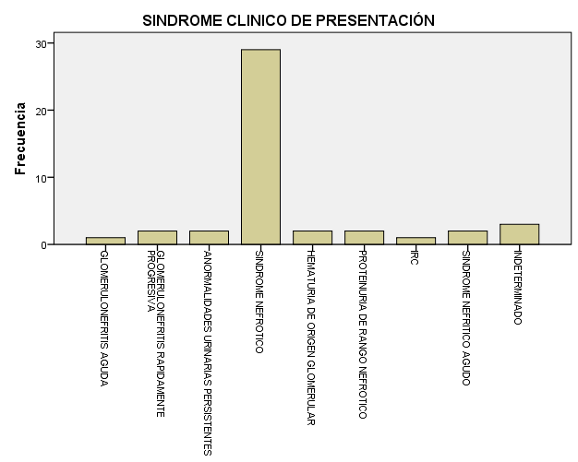

|  |  |  |  |  |  |
| --- | --- | --- | --- | --- | --- |
| **EDAD DEL PACIENTE** | | | | | |
|  | | Frecuencia | Porcentaje | Porcentaje válido | Porcentaje acumulado |
| Válido | 14 | 4 | 8.9 | 9.1 | 9.1 |
| 15 | 1 | 2.2 | 2.3 | 11.4 |
| 16 | 1 | 2.2 | 2.3 | 13.6 |
| 19 | 1 | 2.2 | 2.3 | 15.9 |
| 20 | 1 | 2.2 | 2.3 | 18.2 |
| 22 | 1 | 2.2 | 2.3 | 20.5 |
| 27 | 1 | 2.2 | 2.3 | 22.7 |
| 28 | 1 | 2.2 | 2.3 | 25.0 |
| 30 | 1 | 2.2 | 2.3 | 27.3 |
| 32 | 2 | 4.4 | 4.5 | 31.8 |
| 33 | 1 | 2.2 | 2.3 | 34.1 |
| 35 | 1 | 2.2 | 2.3 | 36.4 |
| 36 | 1 | 2.2 | 2.3 | 38.6 |
| 37 | 2 | 4.4 | 4.5 | 43.2 |
| 38 | 2 | 4.4 | 4.5 | 47.7 |
| 39 | 1 | 2.2 | 2.3 | 50.0 |
| 40 | 1 | 2.2 | 2.3 | 52.3 |
| 41 | 1 | 2.2 | 2.3 | 54.5 |
| 43 | 2 | 4.4 | 4.5 | 59.1 |
| 47 | 1 | 2.2 | 2.3 | 61.4 |
| 49 | 1 | 2.2 | 2.3 | 63.6 |
| 52 | 3 | 6.7 | 6.8 | 70.5 |
| 53 | 3 | 6.7 | 6.8 | 77.3 |
| 54 | 2 | 4.4 | 4.5 | 81.8 |
| 56 | 1 | 2.2 | 2.3 | 84.1 |
| 57 | 1 | 2.2 | 2.3 | 86.4 |
| 59 | 1 | 2.2 | 2.3 | 88.6 |
| 60 | 1 | 2.2 | 2.3 | 90.9 |
| 62 | 1 | 2.2 | 2.3 | 93.2 |
| 71 | 1 | 2.2 | 2.3 | 95.5 |
| 81 | 1 | 2.2 | 2.3 | 97.7 |
| 85 | 1 | 2.2 | 2.3 | 100.0 |
| Total | 44 | 97.8 | 100.0 |  |
| Perdidos | Sistema | 1 | 2.2 |  |  |
| Total | | 45 | 100.0 |  |  |

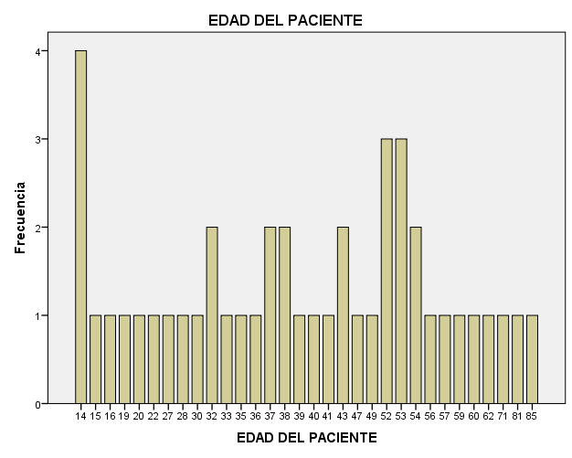

|  |  |  |  |  |  |
| --- | --- | --- | --- | --- | --- |
| **NUMERO DE GLOMERULOS** | | | | | |
|  | | Frecuencia | Porcentaje | Porcentaje válido | Porcentaje acumulado |
| Válido | <5 GLOMERULOS | 2 | 4.4 | 4.9 | 4.9 |
| 5-10 GLOMERULOS | 21 | 46.7 | 51.2 | 56.1 |
| >10 GLOMERULOS | 18 | 40.0 | 43.9 | 100.0 |
| Total | 41 | 91.1 | 100.0 |  |
| Perdidos | Sistema | 4 | 8.9 |  |  |
| Total | | 45 | 100.0 |  |  |

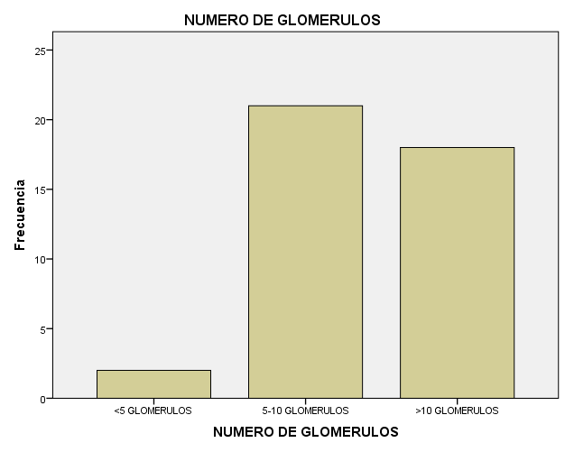

|  |  |  |  |  |  |
| --- | --- | --- | --- | --- | --- |
| **DIAGNOSTICO DEFINITIVO** | | | | | |
|  | | Frecuencia | Porcentaje | Porcentaje válido | Porcentaje acumulado |
| Válido | GLOMERULOPATIA DE CAMBIOS MINIMOS PRIMARIA | 4 | 8.9 | 10.0 | 10.0 |
| GLOMERULOPATIA MEMBRANOSA PRIMARIA | 9 | 20.0 | 22.5 | 32.5 |
| GLOMERULOESCLEROSIS FOCAL Y SEGMENTARIA | 12 | 26.7 | 30.0 | 62.5 |
| GLOMERULOPATIA MEMBRANOPROLIFERATIVA TIPO I PRIMARIA | 3 | 6.7 | 7.5 | 70.0 |
| GLOMERULONEFRITIS PROLIFERATIVA ENDOCAPILAR PRIMARIA | 2 | 4.4 | 5.0 | 75.0 |
| GLOMERULOPATIA MEMBRANOSA SECUNDARIA | 1 | 2.2 | 2.5 | 77.5 |
| NEFROPATIA IgA SECUNDARIA | 1 | 2.2 | 2.5 | 80.0 |
| GLOMERULONEFRITIS EXTRACAPILAR SECUNDARIA | 1 | 2.2 | 2.5 | 82.5 |
| GLOMERULOESCLEROSIS DIABETICA | 1 | 2.2 | 2.5 | 85.0 |
| GLOMERULONEFRITIS LUPICA TIPO III | 2 | 4.4 | 5.0 | 90.0 |
| GLOMERULONEFRITIS LUPICA TIPO IV | 2 | 4.4 | 5.0 | 95.0 |
| GLOMERULONEFRITIS LUPICA TIPO V | 1 | 2.2 | 2.5 | 97.5 |
| NECROSIS TUBULAR AGUDA | 1 | 2.2 | 2.5 | 100.0 |
| Total | 40 | 88.9 | 100.0 |  |
| Perdidos | Sistema | 5 | 11.1 |  |  |
| Total | | 45 | 100.0 |  |  |

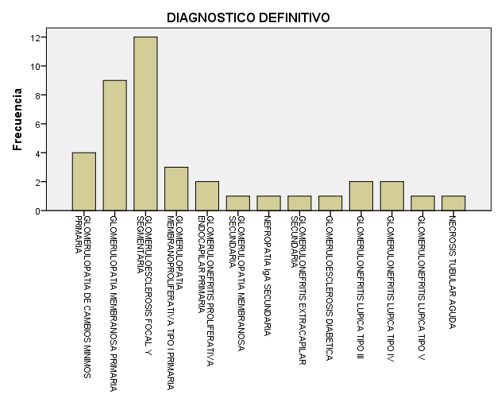

|  |  |  |  |  |  |
| --- | --- | --- | --- | --- | --- |
| **COMPLICACIONES MENORES** | | | | | |
|  | | Frecuencia | Porcentaje | Porcentaje válido | Porcentaje acumulado |
| Válido | HEMATURIA MICROSCOPICA | 22 | 48.9 | 62.9 | 62.9 |
| NINGUNA | 13 | 28.9 | 37.1 | 100.0 |
| Total | 35 | 77.8 | 100.0 |  |
| Perdidos | Sistema | 10 | 22.2 |  |  |
| Total | | 45 | 100.0 |  |  |

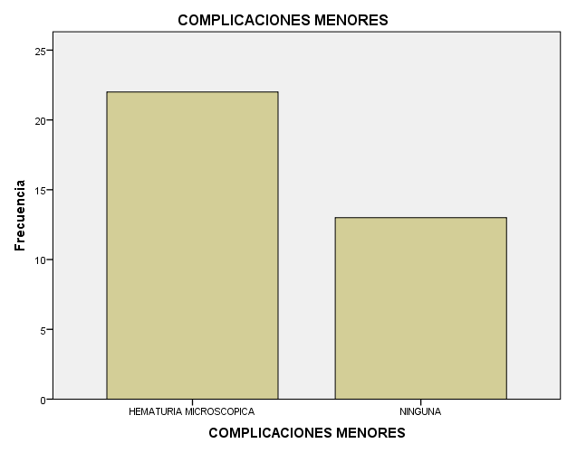

|  |  |  |  |  |  |
| --- | --- | --- | --- | --- | --- |
| **COMPLICACIONES MAYORES** | | | | | |
|  | | Frecuencia | Porcentaje | Porcentaje válido | Porcentaje acumulado |
| Válido | NINGUNA | 35 | 77.8 | 100.0 | 100.0 |
| Perdidos | Sistema | 10 | 22.2 |  |  |
| Total | | 45 | 100.0 |  |  |

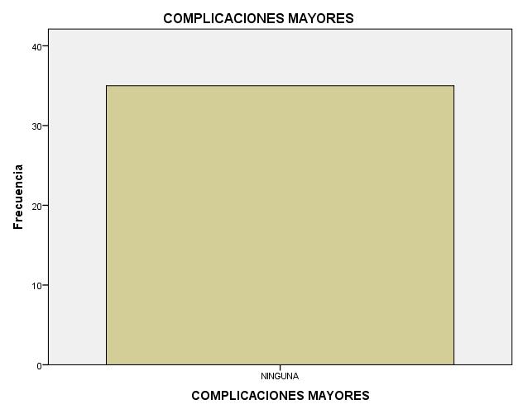

|  |  |  |  |  |  |
| --- | --- | --- | --- | --- | --- |
| **ULTRASONIDO POST BIOPSIA** | | | | | |
|  | | Frecuencia | Porcentaje | Porcentaje válido | Porcentaje acumulado |
| Válido | SIN HEMATOMA | 34 | 75.6 | 100.0 | 100.0 |
| Perdidos | Sistema | 11 | 24.4 |  |  |
| Total | | 45 | 100.0 |  |  |

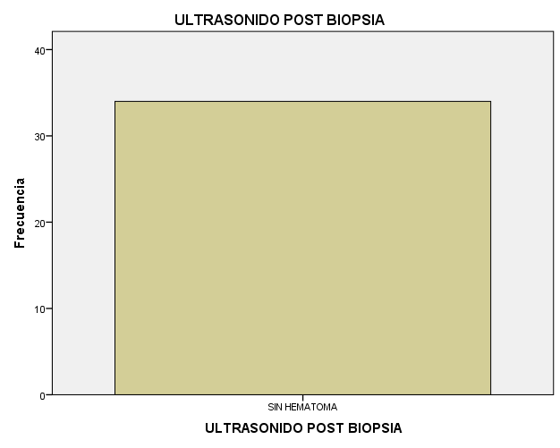

|  |  |  |  |  |  |
| --- | --- | --- | --- | --- | --- |
| **HEMOGLOBINA POST BIOPSIA** | | | | | |
|  | | Frecuencia | Porcentaje | Porcentaje válido | Porcentaje acumulado |
| Válido | SIN REDUCCION <1 gr | 25 | 55.6 | 89.3 | 89.3 |
| CON REDUCCION >1 gr | 3 | 6.7 | 10.7 | 100.0 |
| Total | 28 | 62.2 | 100.0 |  |
| Perdidos | Sistema | 17 | 37.8 |  |  |
| Total | | 45 | 100.0 |  |  |

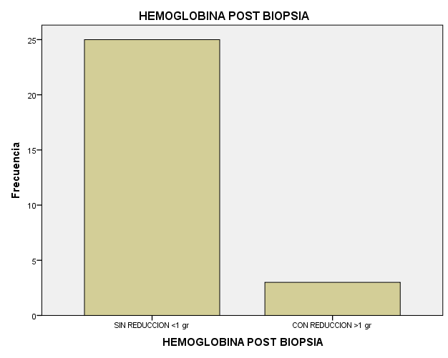

|  |  |  |  |  |  |
| --- | --- | --- | --- | --- | --- |
| **ANALISIS DE ORINA POST BIOPSIA** | | | | | |
|  | | Frecuencia | Porcentaje | Porcentaje válido | Porcentaje acumulado |
| Válido | SIN HEMATURIA MICROSCOPICA | 27 | 60.0 | 96.4 | 96.4 |
| CON HEMATURIA MICROSCOPICA | 1 | 2.2 | 3.6 | 100.0 |
| Total | 28 | 62.2 | 100.0 |  |
| Perdidos | Sistema | 17 | 37.8 |  |  |
| Total | | 45 | 100.0 |  |  |

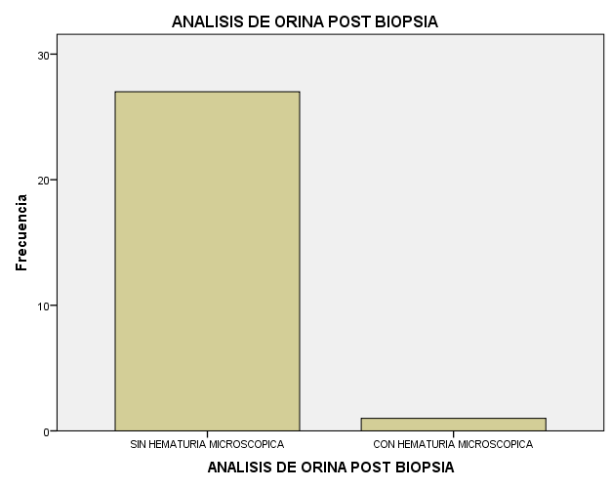

|  |  |  |  |  |  |
| --- | --- | --- | --- | --- | --- |
| **CREATININA AL MES** | | | | | |
|  | | Frecuencia | Porcentaje | Porcentaje válido | Porcentaje acumulado |
| Válido | .60 | 3 | 6.7 | 14.3 | 14.3 |
| .70 | 2 | 4.4 | 9.5 | 23.8 |
| .71 | 1 | 2.2 | 4.8 | 28.6 |
| .90 | 2 | 4.4 | 9.5 | 38.1 |
| 1.00 | 3 | 6.7 | 14.3 | 52.4 |
| 1.20 | 2 | 4.4 | 9.5 | 61.9 |
| 1.25 | 1 | 2.2 | 4.8 | 66.7 |
| 1.30 | 1 | 2.2 | 4.8 | 71.4 |
| 1.50 | 1 | 2.2 | 4.8 | 76.2 |
| 2.00 | 2 | 4.4 | 9.5 | 85.7 |
| 2.49 | 1 | 2.2 | 4.8 | 90.5 |
| 5.90 | 1 | 2.2 | 4.8 | 95.2 |
| 9.00 | 1 | 2.2 | 4.8 | 100.0 |
| Total | 21 | 46.7 | 100.0 |  |
| Perdidos | Sistema | 24 | 53.3 |  |  |
| Total | | 45 | 100.0 |  |  |

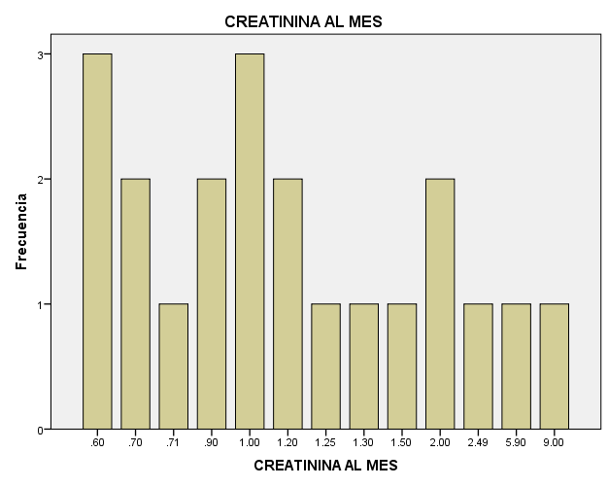

|  |  |  |  |  |  |
| --- | --- | --- | --- | --- | --- |
| **ALBUMINURIA AL MES** | | | | | |
|  | | Frecuencia | Porcentaje | Porcentaje válido | Porcentaje acumulado |
| Válido | .10 | 2 | 4.4 | 10.5 | 10.5 |
| .20 | 1 | 2.2 | 5.3 | 15.8 |
| .40 | 1 | 2.2 | 5.3 | 21.1 |
| .90 | 1 | 2.2 | 5.3 | 26.3 |
| 1.00 | 3 | 6.7 | 15.8 | 42.1 |
| 1.50 | 1 | 2.2 | 5.3 | 47.4 |
| 2.00 | 2 | 4.4 | 10.5 | 57.9 |
| 2.80 | 1 | 2.2 | 5.3 | 63.2 |
| 3.30 | 1 | 2.2 | 5.3 | 68.4 |
| 4.40 | 1 | 2.2 | 5.3 | 73.7 |
| 5.90 | 1 | 2.2 | 5.3 | 78.9 |
| 10.00 | 2 | 4.4 | 10.5 | 89.5 |
| 2191.80 | 1 | 2.2 | 5.3 | 94.7 |
| 4793.00 | 1 | 2.2 | 5.3 | 100.0 |
| Total | 19 | 42.2 | 100.0 |  |
| Perdidos | Sistema | 26 | 57.8 |  |  |
| Total | | 45 | 100.0 |  |  |

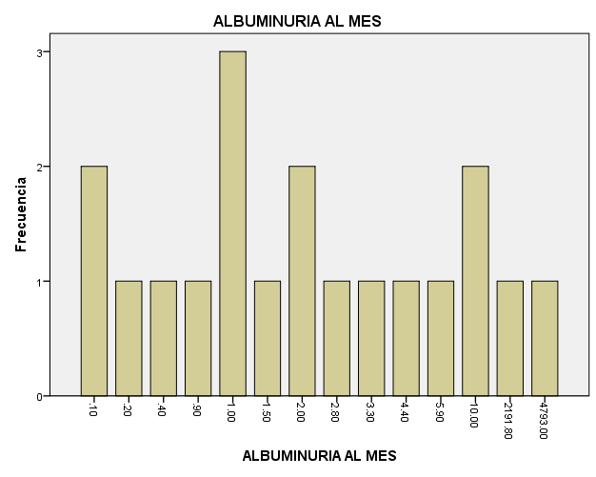

|  |  |  |  |  |  |
| --- | --- | --- | --- | --- | --- |
| **CREATININA A LOS SEIS MESES** | | | | | |
|  | | Frecuencia | Porcentaje | Porcentaje válido | Porcentaje acumulado |
| Válido | .60 | 1 | 2.2 | 5.0 | 5.0 |
| .70 | 3 | 6.7 | 15.0 | 20.0 |
| .79 | 1 | 2.2 | 5.0 | 25.0 |
| .80 | 2 | 4.4 | 10.0 | 35.0 |
| .90 | 1 | 2.2 | 5.0 | 40.0 |
| .97 | 1 | 2.2 | 5.0 | 45.0 |
| 1.00 | 2 | 4.4 | 10.0 | 55.0 |
| 1.10 | 1 | 2.2 | 5.0 | 60.0 |
| 1.20 | 3 | 6.7 | 15.0 | 75.0 |
| 1.26 | 1 | 2.2 | 5.0 | 80.0 |
| 1.80 | 1 | 2.2 | 5.0 | 85.0 |
| 1.82 | 1 | 2.2 | 5.0 | 90.0 |
| 2.00 | 1 | 2.2 | 5.0 | 95.0 |
| 12.00 | 1 | 2.2 | 5.0 | 100.0 |
| Total | 20 | 44.4 | 100.0 |  |
| Perdidos | Sistema | 25 | 55.6 |  |  |
| Total | | 45 | 100.0 |  |  |

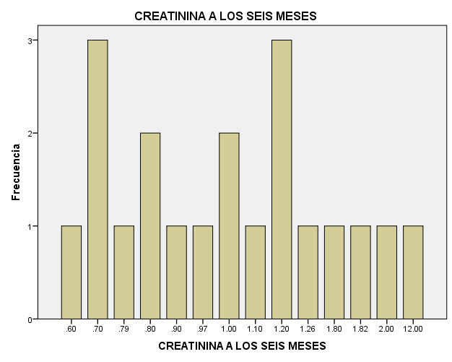

|  |  |  |  |  |  |
| --- | --- | --- | --- | --- | --- |
| **ALBUMINURIA A LOS SEIS MESES** | | | | | |
|  | | Frecuencia | Porcentaje | Porcentaje válido | Porcentaje acumulado |
| Válido | .05 | 1 | 2.2 | 5.9 | 5.9 |
| .10 | 4 | 8.9 | 23.5 | 29.4 |
| .20 | 3 | 6.7 | 17.6 | 47.1 |
| .50 | 1 | 2.2 | 5.9 | 52.9 |
| 1.00 | 4 | 8.9 | 23.5 | 76.5 |
| 3.60 | 1 | 2.2 | 5.9 | 82.4 |
| 5.00 | 1 | 2.2 | 5.9 | 88.2 |
| 11.00 | 1 | 2.2 | 5.9 | 94.1 |
| 3264.00 | 1 | 2.2 | 5.9 | 100.0 |
| Total | 17 | 37.8 | 100.0 |  |
| Perdidos | Sistema | 28 | 62.2 |  |  |
| Total | | 45 | 100.0 |  |  |

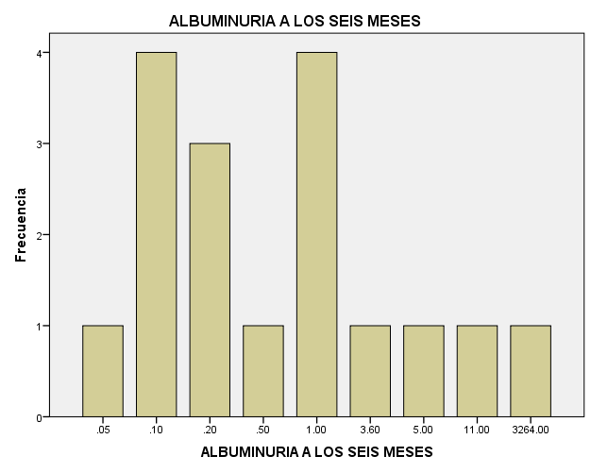

|  |  |  |  |  |  |
| --- | --- | --- | --- | --- | --- |
| **CREATININA A LOS DOCE MESES** | | | | | |
|  | | Frecuencia | Porcentaje | Porcentaje válido | Porcentaje acumulado |
| Válido | .69 | 1 | 2.2 | 6.7 | 6.7 |
| .70 | 1 | 2.2 | 6.7 | 13.3 |
| .75 | 1 | 2.2 | 6.7 | 20.0 |
| .80 | 1 | 2.2 | 6.7 | 26.7 |
| .91 | 1 | 2.2 | 6.7 | 33.3 |
| 1.00 | 2 | 4.4 | 13.3 | 46.7 |
| 1.20 | 2 | 4.4 | 13.3 | 60.0 |
| 1.25 | 1 | 2.2 | 6.7 | 66.7 |
| 1.50 | 1 | 2.2 | 6.7 | 73.3 |
| 1.80 | 1 | 2.2 | 6.7 | 80.0 |
| 3.00 | 2 | 4.4 | 13.3 | 93.3 |
| 5.60 | 1 | 2.2 | 6.7 | 100.0 |
| Total | 15 | 33.3 | 100.0 |  |
| Perdidos | Sistema | 30 | 66.7 |  |  |
| Total | | 45 | 100.0 |  |  |

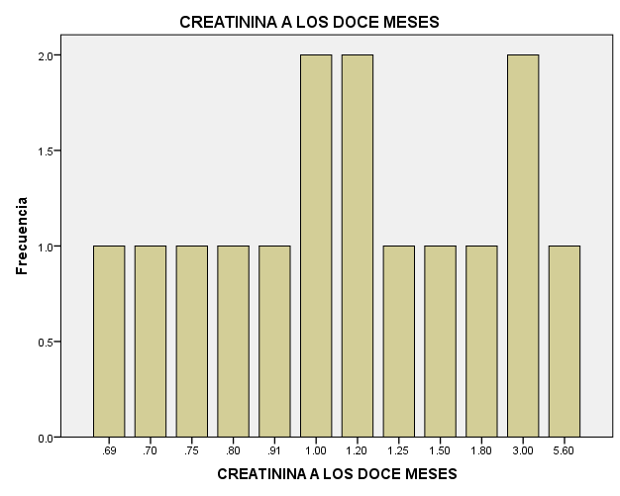

|  |  |  |  |  |  |
| --- | --- | --- | --- | --- | --- |
| **ALBUMINURIA A LOS DOCE MESES** | | | | | |
|  | | Frecuencia | Porcentaje | Porcentaje válido | Porcentaje acumulado |
| Válido | .02 | 1 | 2.2 | 9.1 | 9.1 |
| .07 | 1 | 2.2 | 9.1 | 18.2 |
| .20 | 3 | 6.7 | 27.3 | 45.5 |
| .30 | 1 | 2.2 | 9.1 | 54.5 |
| 1.50 | 2 | 4.4 | 18.2 | 72.7 |
| 115.20 | 1 | 2.2 | 9.1 | 81.8 |
| 338.00 | 1 | 2.2 | 9.1 | 90.9 |
| 28182.00 | 1 | 2.2 | 9.1 | 100.0 |
| Total | 11 | 24.4 | 100.0 |  |
| Perdidos | Sistema | 34 | 75.6 |  |  |
| Total | | 45 | 100.0 |  |  |

